

Darshan University

A Project Report on

**“Hospital Management System”**

Under the subject

**Software Engineering (2301CS405)**

B. Tech, Semester – IV

Computer Science & Engineering Department

|  |  |
| --- | --- |
| Submitted By | |
| Student Name: Deep Botadara | Enrollment No.: 24010101614 |
| Academic Year  (2024-2025) | |
| Internal Guide  Prof. R. B. Gondaliya  Darshan University | Dean-DIET  Dr. Gopi Sanghani  Darshan University |

|  |  |
| --- | --- |
|  | **Computer Science & Engineering Department**  **Darshan University** |

**DECLARATION**

We hereby declare that the SRS, submitted along with the **Software Engineering** **(2301CS405)** for entitled **“Hospital Management System”** submitted in partial fulfilment for the Semester-5 of **Bachelor Technology (B. Tech)** in **Computer Science and Engineering (CSE)** Departmentto Darshan University, Rajkot, is a record of the work carried out at **Darshan University, Rajkot** under the supervision of R. B. Gondaliya and that no part of any of report has been directly copied from any students’ reports, without providing due reference.

Deep Botadara

Student’s Signature

Date: __________

|  |  |
| --- | --- |
|  | **Computer Science & Engineering Department**  **Darshan University** |

**CERTIFICATE**

This is to certify that the SRS on **“Hospital Management System” has** been satisfactorily prepared by **Deep Botadara** (**24010101614**) under my guidance in the fulfillment of the course **Software Engineering (2301CS405)** work during the academic year 2024-2025.

|  |  |  |
| --- | --- | --- |
| Internal Guide  Prof. R. B. Gondaliya  Darshan University |  | Dean-DIET  Dr. Gopi Sanghani  Darshan University |

**Acknowledgement**

I wish to express my sincere gratitude to my project guide Prof. R. B. Gondaliyaand all the faculty members for helping me through my project by giving me the necessary suggestions and advices along with their valuable co- ordination in completing this work.

I also thank my parents, friends and all the members of the family for their precious support and encouragement which they had provided in completion of my work. In addition to that, I would also like to mention the Darshan University personals who gave me the permission to use and experience the valuable resources required for the project from the University premises.

Thus, in conclusion to the above said, I once again thank the faculties and members of **Darshan University** for their valuable support in completion of the project.

Thanking You

**Deep Botadara**

**ABSTRACT**

The Hospital Management System is a computerized solution designed to manage the administrative, medical, and financial aspects of a hospital efficiently. This system aims to replace traditional manual processes with a digital framework that streamlines hospital operations. It provides distinct modules for different user roles, including Admin, Doctor, Patient, Staff, and Medical Store Manager, each with tailored access and functionalities. The system offers features such as online patient registration, appointment scheduling, electronic medical records management, and billing.

Admin users can oversee and configure the system, generate reports, and manage hospital resources. Doctors can access patient histories, manage appointments, and create prescriptions, while patients can view their medical records and schedule visits conveniently. Staff members assist with inventory and patient admissions, and the Medical Store Manager ensures the availability and tracking of medical supplies and pharmaceuticals. Additionally, the system supports secure payment processing and insurance claim management.

The primary objective of this system is to enhance efficiency, reduce human errors, and improve the overall quality of healthcare services through automation and accessibility.

**Table of Contents**

List of Figures I

List of Tables II

1 Introduction 1

1.1 Product perspective 1

1.2 Product features 1

1.2.1 There are **Four** different users who will be using this product: 1

1.2.2 The features that are required for the **Doctor** are: 1

1.2.3 The features that are required for the **Hospital Admin** are: 1

1.2.4 The features that are required for the **Patient** are: 1

1.2.5 The features that are required for the **Medical Store Manager** are: 1

1.3 Functional Requirement 2

1.3.1 Doctor: 2

1.3.2 Patient: 2

1.3.3 Hospital Admin: 2

1.3.4 Medical Store Manager: 2

• Add Medicines: Add new medicines to the inventory. 2

• Remove Medicines: Remove expired or discontinued medicines from the inventory. 2

• Order New Medicines: Place orders to restock medicines as required. 2

• Medical Report Analysis: Analyse medical reports to monitor medicine usage trends. 2

2 Design and Implementation Constraints 3

2.1 Use case diagram 3

2.2 Activity diagram and Swimlane diagram 4

2.3 Sequence diagram 6

2.4 State diagram 8

2.5 Class diagram 9

2.6 Data flow diagram 10

2.6.1 Context diagram (level-0) 10

2.6.2 DFD Level-1 10

2.6.3 DFD Level-2 11

3 External interface requirement (Screens) 12

3.1 Screen-1: Registration Form 12

3.2 Screen-2: Login Form 13

3.3 Screen-3: Add borrower book 14

4 Database design 15

4.1 List of Tables 15

5 Stories and Scenario 16

5.1 Story-1: Add New Book in Library Catalogue 16

5.1.1 Scenario# S1.1 16

5.1.2 Scenario# S1.2 16

5.1.3 Scenario# S1.3 16

5.2 Story-2: Search Book 17

5.3 Story-3: Manage due date for borrowed book 17

5.4 Story-4: Renew book 17

5.5 Story-5: Generate a report on book usage and availability 17

6 Test cases 18

7 References 22

# List of Figures

Figure 2.1‑1 Use case diagram for Hospital management system 3

Figure 2.2‑1 Activity diagram for Book Appointment 4

Figure 2.2‑1 Activity diagram for Add Doctor 4  
Figure 2.2‑2 Swimlane diagram for Book Appointment 5

Figure 2.3‑1 Sequence diagram for Book Issue 7

Figure 2.4‑1 State diagram of Book 8

Figure 2.4‑2 State diagram for Librarian 8

Figure 2.5‑1 Class diagram for Library management system 9

Figure 2.6‑1 Context diagram for Library management system 10

Figure 2.6‑2 DFD level-1 for Library management system 10

Figure 2.6‑3 DFD level-2 for Issue book 11

Figure 3.1‑1 Screen-1: Registration Form 12

Figure 3.2‑1 Screen-2: Login Form 13

Figure 3.3‑1 Screen-3: Add borrower book 14

# List of Tables

Table 3.1‑1 Screen element of Registration form 12

Table 3.2‑1 Screen element of Login form 13

Table 3.3‑1 Screen element of Add borrower book 14

Table 4.1‑1 Table: Book 15

Table 4.1‑2 Table: Borrower 15

Table 4.1‑3 Table: Staff 15

Table 4.1‑4 Table: Student 15

# 1 Introduction

## Product perspective

This project aims to modernize the manual hospital management process into an internet-based application, enabling users to access and manage patient records, appointments, billing, and inventory. It is a multi-user platform that handles core hospital functions like Patient Registration, Appointment Scheduling, Billing, and Inventory Management. It is designed to cater to the basic needs of small to medium-sized hospitals, ensuring streamlined operations and improved efficiency.

## Product features

### There are **Four** different users who will be using this product:

* **Doctor**: View Patients, assign medicines, Check Appointments, Request Leave.
* **Hospital Admin**: Add Doctor, Add Laboratories, Pay Salaries, Add Ambulance.
* **Patient**: Book appointments, modify appointments, Make Payment, Track medicines, Log in.
* **Medical Store Manager:** Add medicines, Order for new medicines, medical report analysis.

### The features that are required for the **Doctor** are:

• View patient details, including medical history and treatment progress.

• Assign and update prescriptions and treatment plans.

• Request leaves and notify hospital administration for approval

• Access laboratory test results and provide recommendations.

• Monitor patient discharge summaries and follow-up requirements.

### The features that are required for the **Hospital Admin** are:

• Register and track ambulance availability and assignments.

• Add and manage doctor profiles, including specialties and schedules.

• Register and update laboratory details and services offered.

• Process and manage staff salary payments.

### 1.2.4 The features that are required for the **Patient** are:

• Book new appointments with available doctors.

• Modify or cancel existing appointments.

• Make secure payments for consultations, treatments, and services.

• Track prescribed medicines and purchase status.

• Log in to access personal health records and manage profile details

### 1.2.5 The features that are required for the **Medical Store Manager** are:

• Add and update the inventory of medicines available in the store.

• Place orders for new medicines and restock inventory as needed.

• Analyse medical reports to identify frequently prescribed medicines.

• Monitor expiration dates and remove outdated stock

## Functional Requirement

### Doctor:

* View Patients: Access patient details, and ensure new entries are recorded in the database.
* Assign medicines: Prescribe or update medicines, with changes reflected in the database.
* Check appointments: View schedules and remove incorrect entries.
* Request Leave: Submit leave requests, tracked in the system for approval.

### Patient:

* Book Appointment: Schedule appointments with doctors, ensuring availability.
* Cancel Appointment: Cancel existing appointments when needed.
* Modify Appointment: Modify scheduled appointments with new date/time.
* View Report: Access and view medical test reports.
* Make Payment: Pay for consultations, treatments, and services securely.
* OrderMedicines**:** Order prescribed medicines from the pharmacy
* Track Medicines: Monitor the status of medicine orders and deliveries.
* Log In: Access personal health records and manage account details.

### Hospital Admin:

### Add Doctor: Add new doctor profiles with details and specialties.

### Remove Doctor: Remove doctor profiles from the system.

* Add Medical Store: Register new medical stores and their details.
* Remove Medical Store: Delete medical store entries from the system.
* Add Laboratories: Register new laboratories and their services.
* Remove Laboratories: Remove laboratory records from the system.
* Add Ambulances: Register new ambulances with details for availability.
* Remove Ambulances: Remove ambulance records from the system.
* Pay Salaries: Process and manage staff salary payments.

### Medical Store Manager:

### Add Medicines: Add new medicines to the inventory.

### Remove Medicines: Remove expired or discontinued medicines from the inventory.

### Order New Medicines: Place orders to restock medicines as required.

### Medical Report Analysis: Analyse medical reports to monitor medicine usage trends.

# Design and Implementation Constraints

## Use case diagram

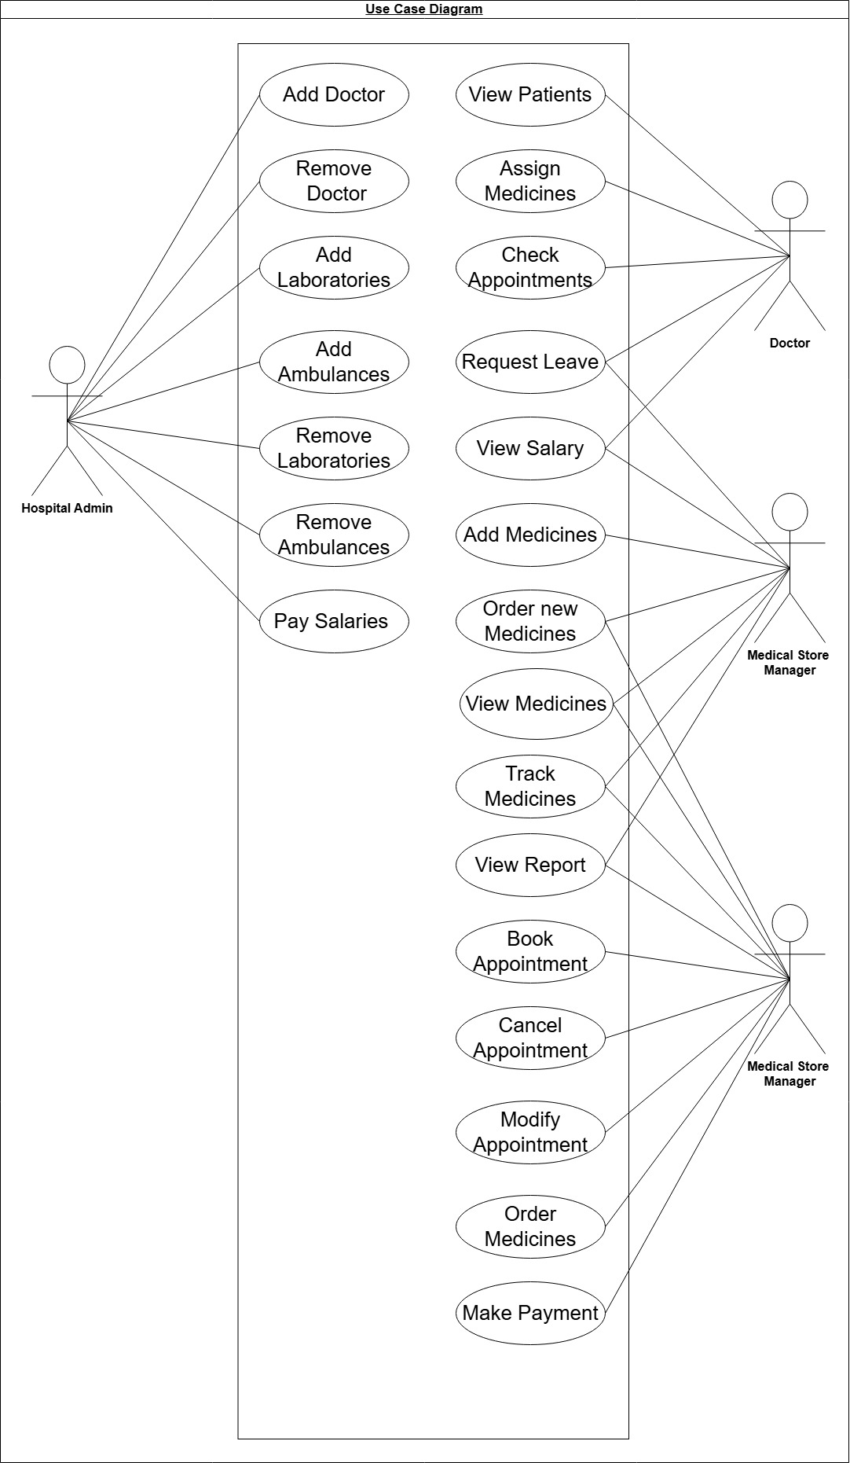Figure ‑ Use case diagram for library management system

## Activity diagram and Swimlane diagram

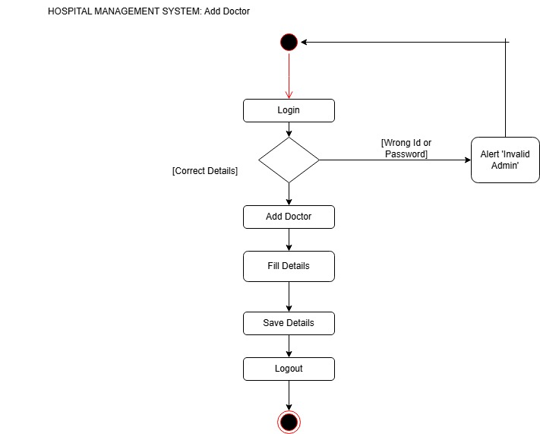

Figure ‑ Activity diagram for Add Doctor

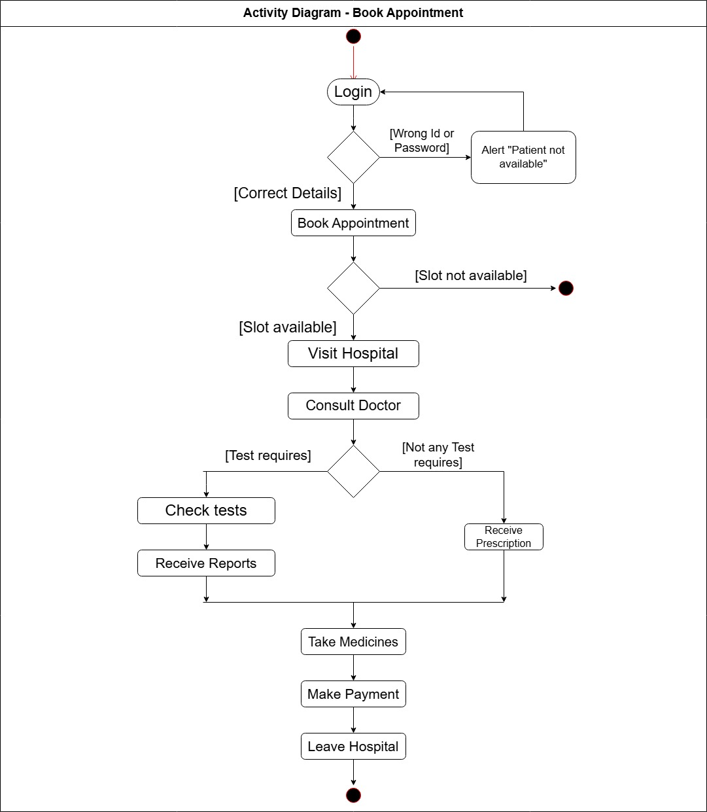

## Swimlane diagram – Book Appointment

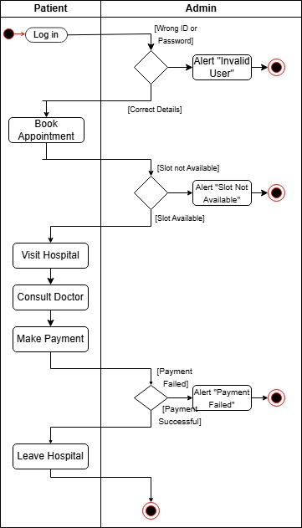

Figure 2.3‑1 Swimlane diagram for Book Appointment

## Sequence diagram- Book Appointment

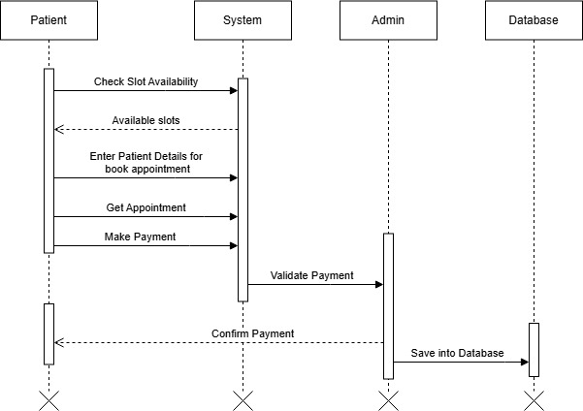

Figure ‑ Sequence diagram for Book Appointment

## State diagram

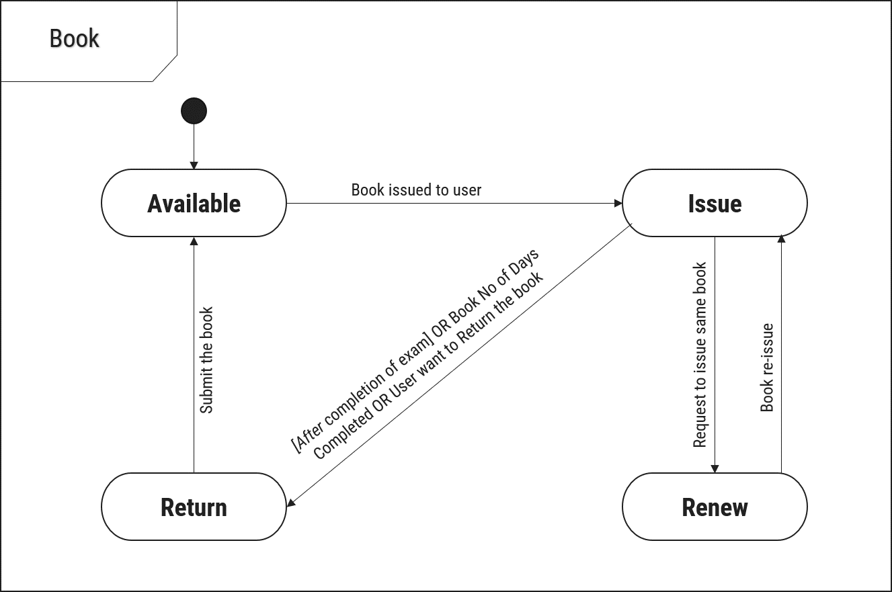

Figure ‑ State diagram of Book

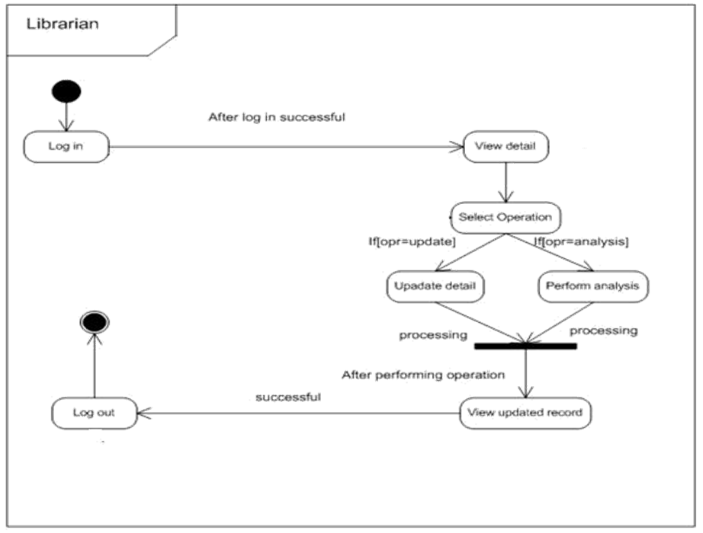

Figure ‑ State diagram for Librarian

## Class diagram

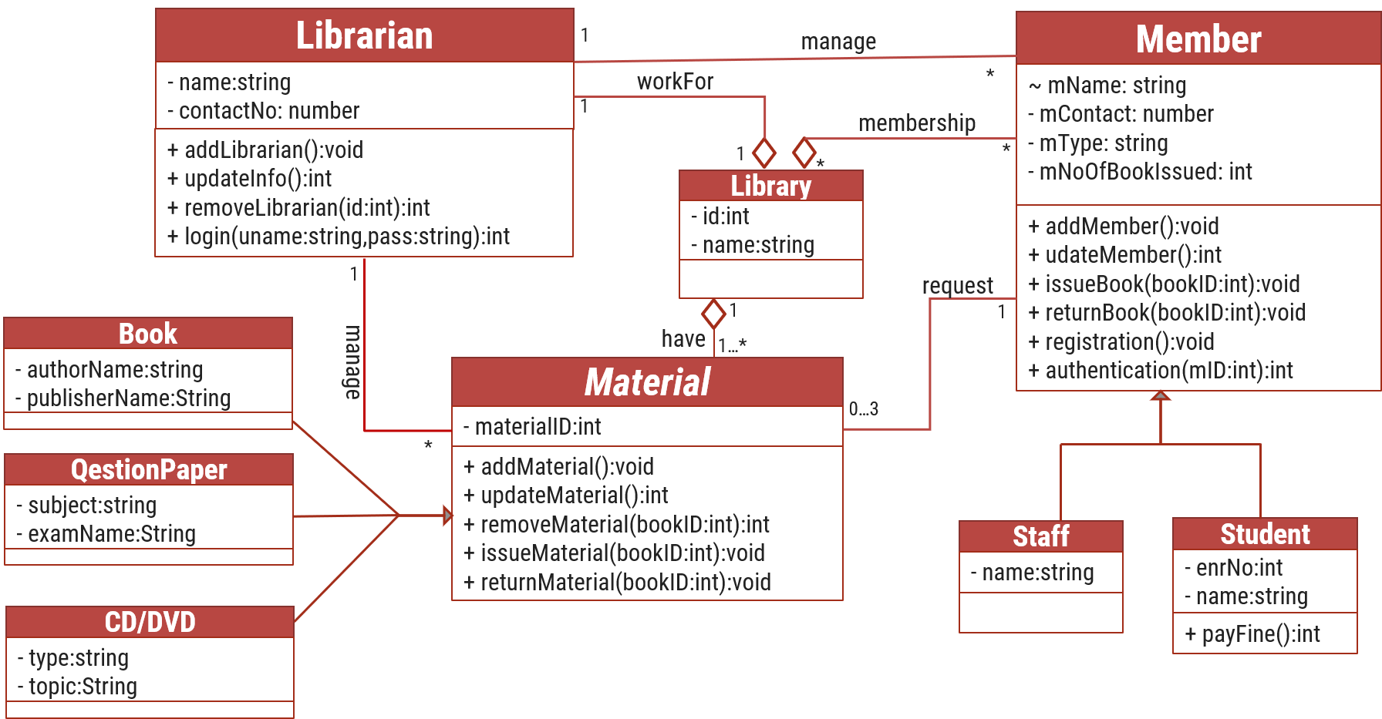

Figure ‑ Class diagram for Library management system

## Data flow diagram

### Context diagram (level-0)

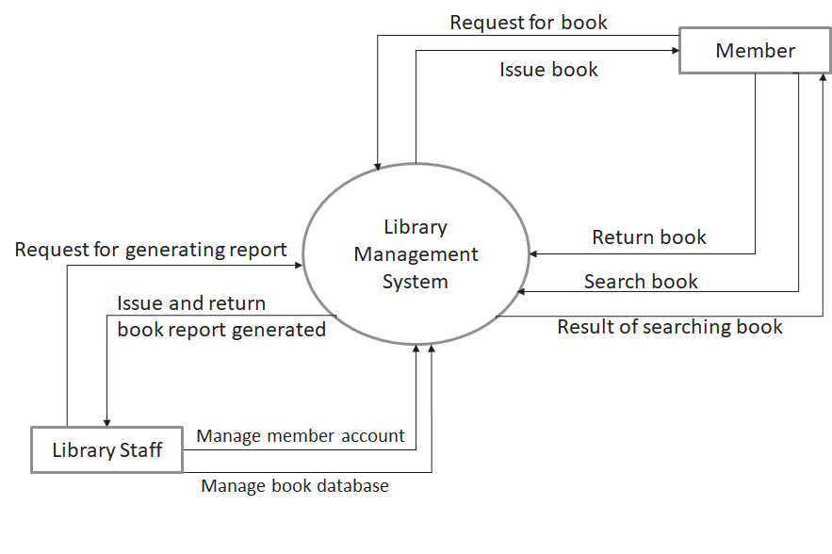

Figure ‑ Context diagram for Library management system

### DFD Level-1

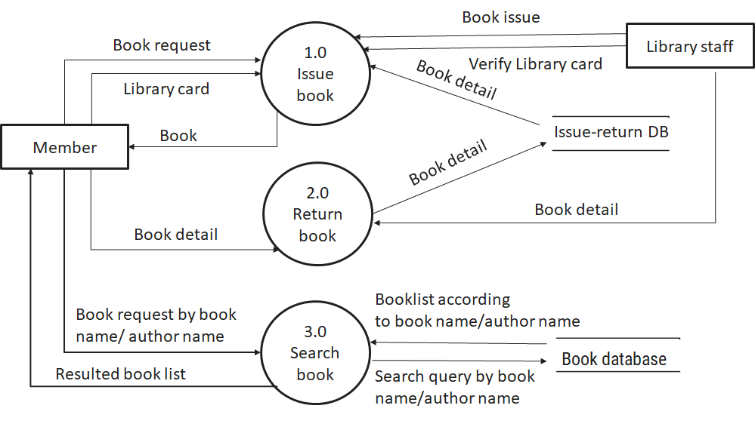

Figure ‑ DFD level-1 for Library management system

### DFD Level-2

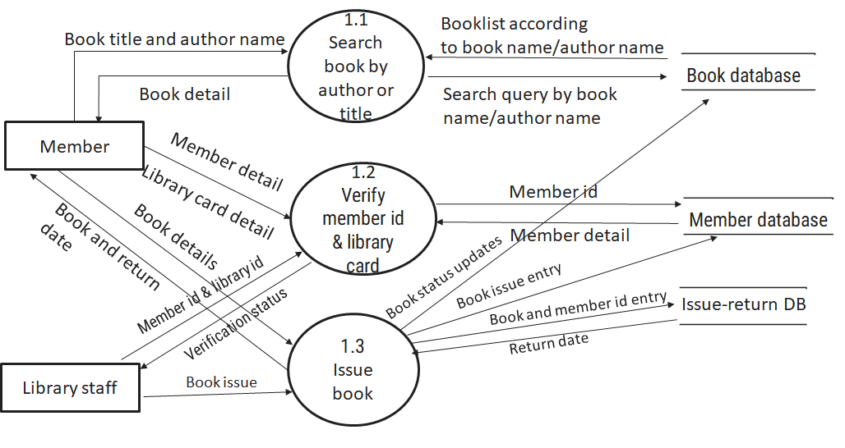

Figure ‑ DFD level-2 for Issue book

# External interface requirement (Screens)

## Screen-1: Registration Form

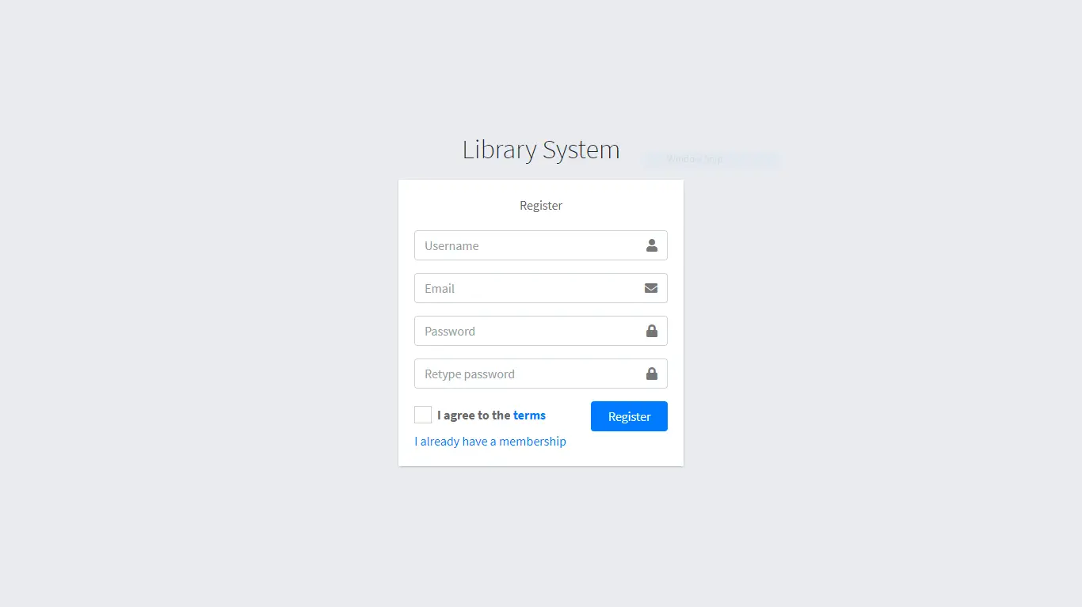

Figure ‑ Screen-1: Registration Form

**Purpose:** This form will allow the target end-users to register in the system. To register , the following information will be encoded in the system.

Table ‑ Screen element of Registration form

|  |  |  |  |  |  |
| --- | --- | --- | --- | --- | --- |
| Sr. | Screen Element | Input Type | O/M | 1/N | Description |
| 1 | Username | Textbox | M | 1 | Username field should be editable and accept the Username. |
| 2 | Email | Textbox | M | 1 | Email field should be editable and accept the email with proper format. |
| 3 | Password | Password | M | 1 | Password field should be editable and accept the password and display as star or dot. |
| 4 | Retype password | Password | M | 1 | Retype Password field should be editable and accept the password and display as star or dot. |
| 5 | I agree to the terms | Checkbox | M | 1 | Checkbox for accepting terms and condition. |
| 6 | I already have a membership | Link | ------ | ------ | Link for navigate to login page for registered user. |
| 7 | Register | Button | ------ | ------ | Register is a button for store the entered data into database. |

## Screen-2: Login Form

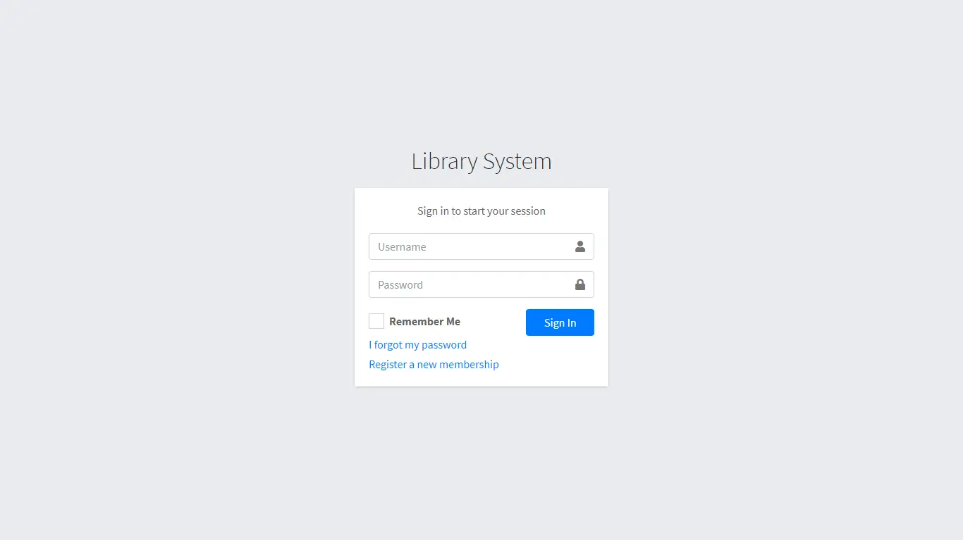

Figure ‑ Screen-2: Login Form

**Purpose:** This form will be used by the system’s users to access records and features of the system. The users will input the correct combination of their username and password to be able to login to the system.

Table ‑ Screen element of Login form

|  |  |  |  |  |  |
| --- | --- | --- | --- | --- | --- |
| Sr. | Screen Element | Input Type | O/M | 1/N | Description |
| 1 | Username | Textbox | M | 1 | Username field should be editable and accept the Username. |
| 2 | Password | Password | M | 1 | Password field should be editable and accept the password and display as star or dot. |
| 3 | Remember Me | Checkbox | M | 1 | Saving login credentials through remember me checkbox |
| 4 | I forgot my password | Link | ------ | ------ | Link for navigate to Forgot password page for allows users to recover password. |
| 5 | Register a new membership | Link | ------ | ------ | Link for navigate to membership registration. |
| 6 | Sign in | Button | ------ | ------ | Login button navigates to another page even if valid login credentials. |

## Screen-3: Add borrower book

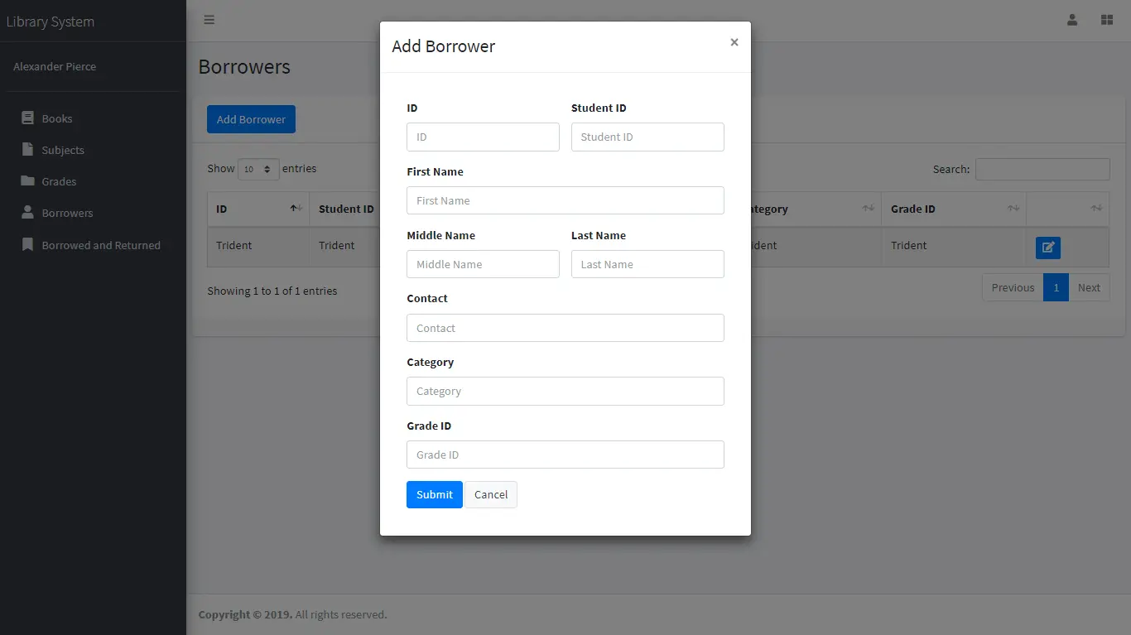

Figure ‑ Screen-3: Add borrower book

**Purpose:** This module will allow the system administrator to add, edit, update or delete borrowers of book. The admin can add borrower information and manage it.

Table ‑ Screen element of Add borrower book

|  |  |  |  |  |  |
| --- | --- | --- | --- | --- | --- |
| Sr. | Screen Element | Input Type | O/M | 1/N | Description |
| 1 | Borrower ID | Textbox | M | 1 | Borrower ID field should be editable and fill autogenerated Borrower ID. |
| 2 | Student ID | Textbox | M | 1 | Student ID field should be editable and accept Student barcode id. |
| 3 | First Name | Textbox | M | 1 | First Name field should be editable and accept only string as a borrower first name. |
| 4 | Middle Name | Textbox | O | 1 | Middle Name field should be editable and accept only string as a borrower middle name. |
| 5 | Last Name | Textbox | M | 1 | Last Name field should be editable and accept only string as a borrower last name. |
| 6 | Contact | Textbox | M | 1 | Contact field should be editable and accept only 10-digit mobile number. |
| 7 | Grade Id | Textbox | O | 1 | Auto fetch detail from the database if proper student id is entered. |
| 8 | Submit | Button | ----- | ----- | Submit is a button for store the entered data into database. |
| 9 | Cancel | Button | ----- | ----- | Cancel is a button for close add borrower dialog. |

# Database design

## List of Tables

* Book
* Borrower
* Student
* Staff

Table ‑ Table: Book

|  |  |  |  |  |
| --- | --- | --- | --- | --- |
| Column | Data Type | Null | Keys & Constrains | Default Value & Description |
| BookID | int | NN | PK (Auto Increment) |  |
| BookName | varchar(100) | NN |  |  |
| ISBN | varchar(100) | AN |  |  |
| Publication_year | int | AN |  |  |
| Language | varchar(50) | AN |  |  |

Table ‑ Table: Borrower

|  |  |  |  |  |
| --- | --- | --- | --- | --- |
| Column | Data Type | Null | Keys & Constrains | Default Value & Description |
| BorrowerID | int | NN | PK (Auto Increment) |  |
| BookID | varchar(100) | NN | FK | Reference of Book Table |
| BorrowedFromDate | DateTime | AN |  |  |
| BorrowedToDate | DateTime | AN |  |  |
| ActualReturnDate | DateTime | AN |  |  |
| IssuedBy | int | NN | FK | Reference of Student and Staff Table |

Table ‑ Table: Staff

|  |  |  |  |  |
| --- | --- | --- | --- | --- |
| Column | Data Type | Null | Keys & Constrains | Default Value & Description |
| StaffID | int | NN | PK (Auto Increment) |  |
| StaffName | varchar(100) | AN |  |  |
| IsAdmin | Boolean | AN |  |  |
| Designation | varchar(100) | AN |  |  |

Table ‑ Table: Student

|  |  |  |  |  |
| --- | --- | --- | --- | --- |
| Column | Data Type | Null | Keys & Constrains | Default Value & Description |
| StudentID | int | NN | PK (Auto Increment) |  |
| StudentName | varchar(100) | AN |  |  |
| Gender | varchar(100) | AN |  |  |
| DOB | DateTime | AN |  |  |
| Department | varchar(100) | AN |  |  |
| Contact | number(10,0) | AN |  |  |

# Stories and Scenario

## Story-1: Add New Book in Library Catalogue

|  |  |  |
| --- | --- | --- |
| *Story # S1* | : | As a Librarian,  I want to add a new book in library catalogue  So that everyone can easily find and borrow it. |
| Priority | **:** | High |
| Estimate | **:** | XL |
| Reason | **:** | The addition of a new book to the library catalogue is crucial for ensuring that the library's collection is up-to-date and accessible to everyone. |

### Scenario# S1.1

|  |  |  |
| --- | --- | --- |
| *Scenario# S1.1* | : | Adding a New Book with Valid Information |
| Prerequisite | **:** | Librarian is logged in to the Library management system. |
| Acceptance Criteria | **:** | **Given:**  The Librarian is navigated to the library catalog management page. Valid book information, including title, author, ISBN, and other relevant details is added.  **When:**  The librarian selects the "Add New Book" option  And The librarian enters valid book details  The librarian clicks the "Save" button to add the book to the catalog.  **Then t**he system successfully adds the book to the catalog and the librarian receives a confirmation message with the book's identification number. |

### Scenario# S1.2

|  |  |  |
| --- | --- | --- |
| *Scenario# S1.2* | : | Adding a New Book with Invalid Information. |
| Prerequisite | **:** | The librarian is logged into the library management system. |
| Acceptance Criteria | **:** | **Given:** The librarian is on the library catalogue management page  **When:** The librarian selects the "Add New Book" option and the librarian enters an incomplete or incorrect book details and librarian clicks the "Save" button to add the book to the catalogue.  **Then t**he system displays error messages for the incorrect or missing information and the book is not added to the catalogue. |

### Scenario# S1.3

|  |  |  |
| --- | --- | --- |
| *Scenario# S1.3* | : | Attempting to Add a Duplicate Book |
| Prerequisite | **:** | The librarian is logged into the library management system and the librarian is on the library catalogue management page |
| Acceptance Criteria | **:** | **Given**: The book information, including title, author, ISBN, and other relevant details, is available and the book with the same ISBN is already in the catalogue.  **When**: User Clicks on “Add book” button. Enter a number of copies with the same book detail mentioned in the field.  **Then**: Generate unique book id, barcode and spine label for various book of same title. |

## Story-2: Search Book

|  |  |  |
| --- | --- | --- |
| *Story # S2* | : | As a Librarian or member,  I want to search for books by title, author, or keyword,  So that I can quickly find books that match my interests. |
| Priority | **:** | High |
| Estimate | **:** | M |
| Reason | **:** | Implementing a search functionality is essential for enhancing the user experience, as it allows librarian and member to efficiently discover and access the library's resources. |

## Story-3: Manage due date for borrowed book

|  |  |  |
| --- | --- | --- |
| *Story # S3* | : | As Librarian,  I want to manage due dates for borrowed books  So that I can ensure that books are returned on time and avoid overdue fines. |
| Priority | **:** | High |
| Estimate | **:** | M |
| Reason | **:** | Proper due date management is crucial for maintaining the library's collection and ensuring that books are available for all members. |

## Story-4: Renew book

|  |  |  |
| --- | --- | --- |
| *Story # S3* | : | As Librarian,  I want to renew a book that I have borrowed  So that I can extend my borrowing period if needed. |
| Priority | **:** | Medium |
| Estimate | **:** | M |
| Reason | **:** | Book renewal functionality is a convenience feature for librarian, allowing them to keep a book for an extended period if no one else has requested it. |

## Story-5: Generate a report on book usage and availability

|  |  |  |
| --- | --- | --- |
| *Story # S3* | : | As Librarian,  I want to generate reports on library usage and book availability  So that I can make informed decisions about library’s books. |
| Priority | **:** | Medium |
| Estimate | **:** | L |
| Reason | **:** | Reporting functionality helps librarians track the usage of library resources and make data-driven decisions to improve services and collections. |

# Test cases

|  |  |  |  |
| --- | --- | --- | --- |
| Project Name: | EMI Calculator | Test Designed by: | P. U. Jadeja |
| Module Name: | **Login** | **Test Designed date:** | 01-10-2023 |
| Release Version: | **1.0** | **Test Executed by:** | **R. B. Gondaliya** |
|  |  | **Test Execution date:** | 15-01-2023 |

|  |  |  |  |  |
| --- | --- | --- | --- | --- |
| Pre-condition: Web application should be accessible | | | | |
| Test Case ID | **Test Title** | **Test Type** | **Description** | **Test Case ID** |
| TC_001 | Login to web application with valid credential | Functional | Login to Library management system web application through valid credential | TC_001 |
| TC_002 | Login to web application with invalid credential | Functional | Login to Library management system web application through invalid credential | TC_002 |
| TC_003 | Varify login page elements | GUI | varify that all elements are availabe on login page | TC_003 |

|  |  |
| --- | --- |
| **Test Case Title** | Login to web application with valid credential |
| **Test Type** | Functional |
| **Test Priority** | High |
| **Pre-condition** | Web application should be accessible |

|  |  |  |  |  |  |  |  |
| --- | --- | --- | --- | --- | --- | --- | --- |
| **Test Step** | **Test Case Description** | **Expected Result** | **Actual Result** | **Status** | **Comment** | **Data** | **BUG ID** |
| 1 | Access Web application URL | The site launched properly | Site launched successfully | Pass |  | <https://accounts.google.com/ServiceLogin> |  |
| 2 | Enter valid Username in username field | Username field should be editable and accept the Username | Username input accepted | Pass |  | Username:  Rbgondaliya@gmail.com |  |
| 3 | Enter valid Password in Password field | Password field should be editable and accept the password and display as star or dot | Password input displayed in dot and accepted | pass |  | Password: rbgondaliya |  |
| 4 | Enter valid captcha code in captch field | Captch field should editable and accept captcha and captcha is case sensitive | Captcha input accepted | Pass | Step required when human action validation perform | get captcha from image which is near by captcha field |  |
| 5 | Click on login button | User should login into site and navigated to dashboard | User navigated to dashboard and username should br display in top of the right side. | pass |  |  |  |

|  |  |
| --- | --- |
| **Test Case Title** | Login to web application with invalid credential |
| **Test Type** | Functional |
| **Test Priority** | Medium |
| **Pre-condition** | Web application should be accessible |

|  |  |  |  |  |  |  |  |
| --- | --- | --- | --- | --- | --- | --- | --- |
| **Test Step** | **Test Case Description** | **Expected Result** | **Actual Result** | **Status** | **Comment** | **Data** | **Bug ID** |
| 1 | Verify that User is not able to Login with invalid Username and invalid Password | Should be display an error message enter wrong username or password | Display an error of wrong username and password | Pass |  |  |  |
| 2 | Verify that User is not able to Login with Valid Username and invalid Password | Should be display an error message enter wrong password | Display an error of wrong password | Pass |  |  |  |
| 3 | Verify that User is not able to Login with invalid Username and Valid Password | Should be display an error message User not found | Display an error Username not found | Pass |  |  |  |
| 4 | Verify that User is not able to Login with blank Username or Password | Set required field validation message for Username and Password | Display an error of wrong username and password | Fail | Not performa a validation function fix it |  | Bug_002 |

|  |  |
| --- | --- |
| **Test Case Title** | Varify login page elements |
| **Test Type** | GUI |
| **Test Priority** | Medium |
| **Pre-condition** | Web application should be accessible |

|  |  |  |  |  |  |  |  |
| --- | --- | --- | --- | --- | --- | --- | --- |
| **Test Step** | **Test Case Description** | **Expected Result** | **Actual Result** | **Status** | **Comment** | **Data** | **Bug ID** |
| 1 | Launch application with the given url | The site launched properly | Site launched successfully | Pass |  | <https://accounts.google.com/ServiceLogin> |  |
| 2 | Verify that the login screen contains elements such as Username, Password, Sign in button, Remember password check box, Forgot password link, and Create an account link. | All listed control displayed properly on the page | Login page loaded successfully | Pass |  |  |  |
| 3 | Verify that cursor is focused on “Username” text box on the page load | Cursor is focused in Username textbox | Cursor focus in Username textbox | Pass |  |  |  |
| 4 | Verify that tab functionality is working properly or not | When tab pressed cursor move in next control | Cursor moving in next control | Pass |  |  |  |
| 5 | Verify that all the fields such as Username, Password has a valid placeholder | All text fields have proper placeholder | All text fields have proper placeholder | Pass |  |  |  |
| 6 | Verify that the labels float upward when the text field is in focus or filled (In case of floating label) | When field is focused or filled, label display on top of the filled | When field is focus or filled, label display on top of the filled | Pass | step required when fields with floating label |  |  |
| 7 | verify that forgot password link working properly | when click on forgot password load forgot passworg page | forgot password link not working | Fail |  |  |  |

# References

* http://www.w3schools.com/html/html_intro.asp
* https://www.w3schools.com/php/default.asp
* https://www.javatpoint.com/uml